**CS 550 Final Project Report**

**Name: Haotian Jia**

**E-mail:** [**jiahao@oregonstate.edu**](mailto:jiahao@oregonstate.edu)

**Link:** [**https://media.oregonstate.edu/media/1_qrnnlh3s**](https://media.oregonstate.edu/media/1_qrnnlh3s)

**I. Abstract**

In the final project, I designed a “Disco-ball surround model”. Therefore, in this report, I will describe my report based on the following parts, namely the Proposal, Achievements, Differences, Things I Learned and Related Images.

**II. Proposal**

For the final project, I want to use multiple spheres to compose what it looks like.

Firstly, the main part of the project is divided into two parts. The first part is to create a center point at the highest point of all spheres, and it is also the center point of all 3D objects, because I want to treat it as a “Disco-ball”. So, it has the effects of lighting and texture mapping.

In addition, the second part is to create at least six or more spheres. Here I take the creation of six spheres as an example. Since in the first part I have set the largest sphere as the center and located at the highest point of all other objects, so I created a circle with the dotted line below the largest sphere from the distance (Assuming its radius is $R_{1}$). Then place three spheres on the outline of the ring. In the same way, set a new circle formed by a dotted line below the distance above the circle, its radius is $R_{2}$ and $R_{2}=2R_{1}$. These spheres have lighting, texture graphics, and rotation effects.

Depending on the actual situation, I think I will modify this final project.

**III. Achievements**

I met the requirements of the proposal. Firstly, I created a sphere at the top, which has lighting and texture effects. Then, I distinguished the next two layers according to the distance between each layer. Each layer has three spheres, which can be rotated and other operations.

Fig. 1 and Fig. 2 are brief sketch introduction:

**Fig. 1 Fig. 2**

For details of related images, go to Part VI – Related images.

Fig. 3 shows the “Disco-ball surround model” in the top view. It is a comparison with the Fig. 1.

Fig. 4 shows the “Disco-ball surround model” in the side view. It is a comparison with the Fig. 2.

Fig. 5 shows the normal effect of the “Disco-ball surround model” with the lighting.

**IV. Differences**

I think the biggest difference between my actual operation and my proposal this time is the speed of the two parts of the disco ball.

First of all, my initial idea was to set the speed of the sphere in the middle layer to one unit and the speed of the sphere in the bottom layer to two units, which is twice the speed of the sphere in the middle layer. But in actual operation, I found that the speed of the middle layer looks more reasonable and considerable. Therefore, I appropriately modified the rotation speed of the different sphere layers.

**V. Things I Learned**

This final project has a lot of challenges for me, it includes two aspects of object animation and texture.

Firstly, about the animation of the object. Since all spheres need to rotate around a fixed orbit and a fixed circle, I need to make reasonable settings to make them centered around the Disco-ball to prevent them from falling out of track.

In addition, about the texture. The texture of different spheres is almost different. I chose different texture pictures for all the spheres in the two layers. These pictures include pictures of some balls, such as basketball, golf, soccer, football and so on. Besides, I downloaded these pictures on the Internet to meet the requirements of various textures.

**VI. Related Images**

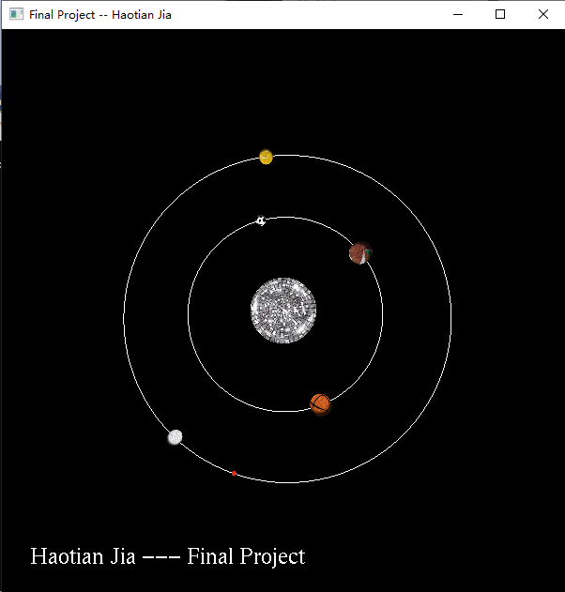

**Fig. 3**

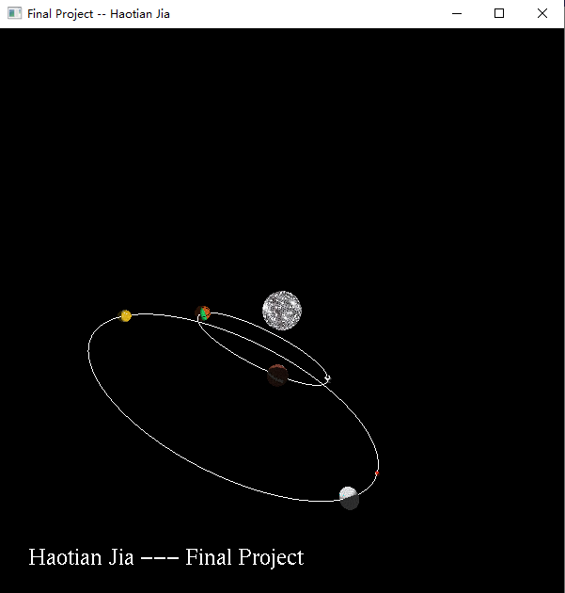

**Fig. 4**

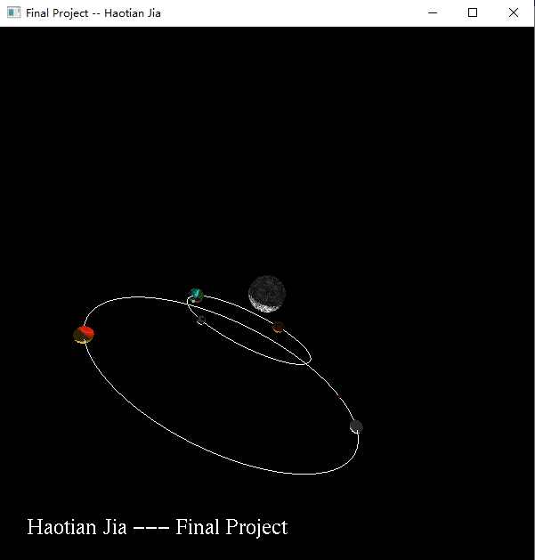

**Fig. 5**